**Day 1 Lab Assignments**

1. Design the following sample home page using the following main layout for Desktop (and make sure that it’s completely **responsive**):

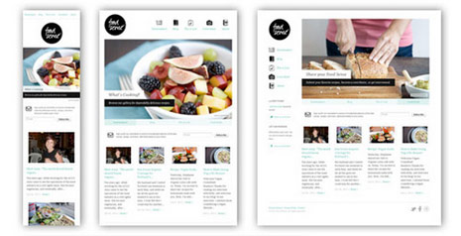

1. Use Media query and CSS breakpoints in your website layout on normal laptops and PCs, tablets and smart phones (as shown in the prev. image):
   1. You can use your old home page layout (In JS labs) instead of the following image if you like)
   2. Design the tablet view, and hide the left column on tablet size and make the middle part fill the width. (Use media queries on CSS file and breakpoints).
   3. When you hide the left column, make it appear as row (width 100%) above or below (as shown in above image for tablet view).
   4. Design the mobile view hide banner image and left column (Use media queries on CSS file and breakpoints).



1. Use grid layout with your CV page design, and make sure that it’s completely responsive (use viewport meta tag):
   1. Change the middle content in the given image to be full-page width.
   2. Use 16 columns layout.
   3. Set box-sizing property.
   4. Use Viewport units with the font size for text in the header (Name), and max-width with the image.
   5. Use float property or flexbox.